Why is JavaScript hoisting?

In JavaScript, Hoisting is the default behavior of moving all the declarations at the top of the scope before code execution. Basically, **it gives us an advantage that no matter where functions and variables are declared, they are moved to the top of their scope regardless of whether their scope is global or local**.

Variable hoisting we can learn from var, let ,const document.

Function hoisting

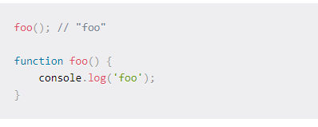

 only function *declarations* are hoisted, not function *expressions*.

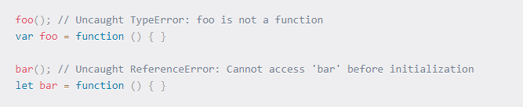

 function expression was assigned to, we will get a TypeError or ReferenceError

**The function expressions and arrow functions cannot be hoisted**.

